# Assignment 2

## Screenshots of two files generated –

1.

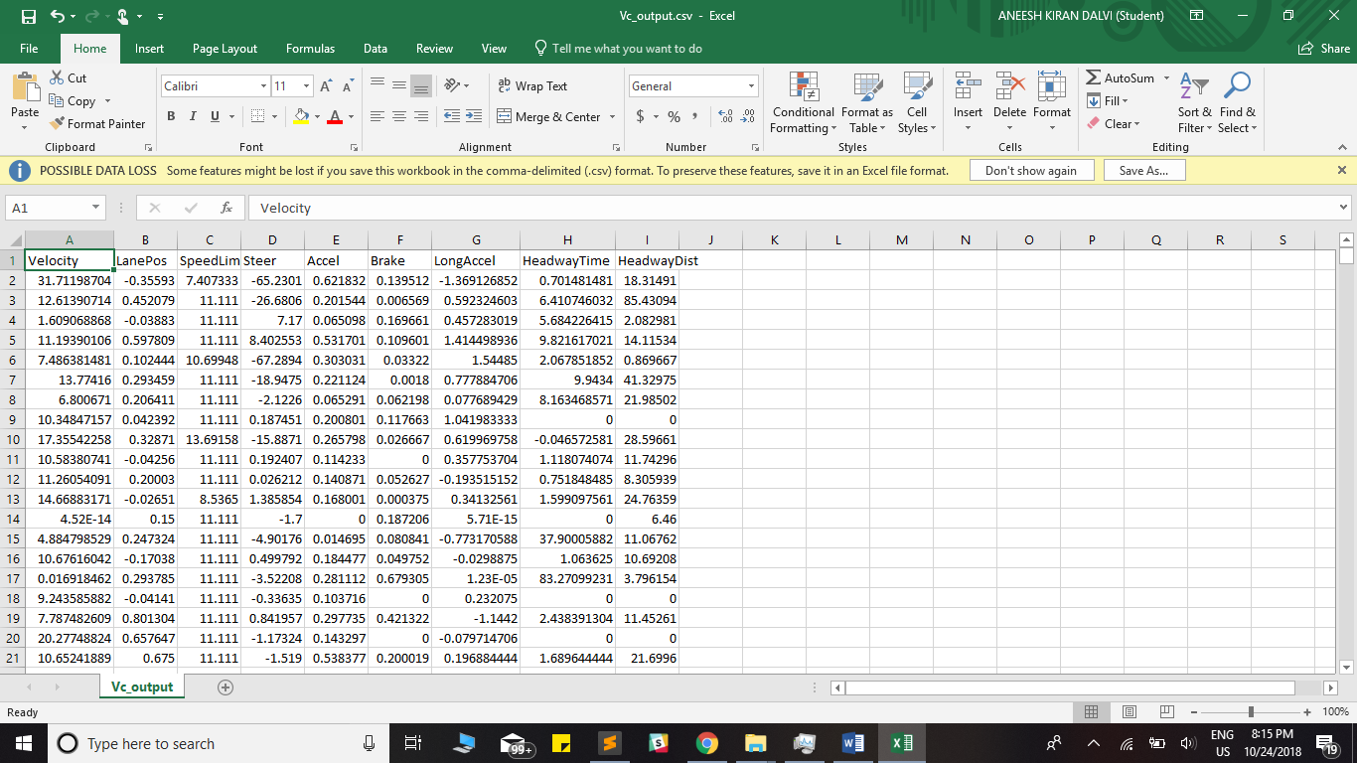

2.

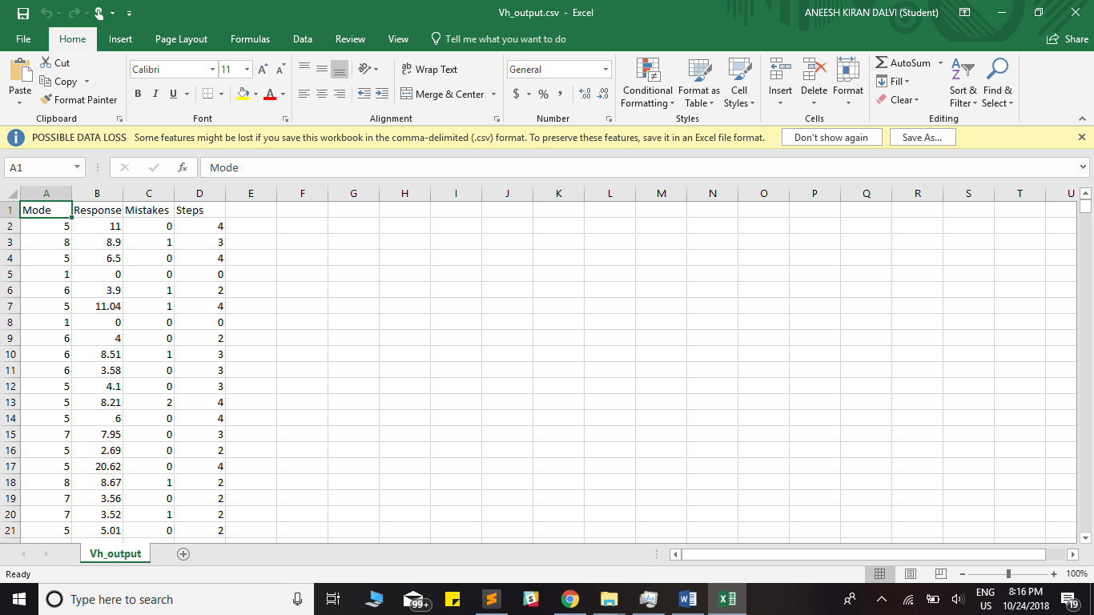

## Source Code – FileReader2.py

import pandas as pd

from pandas import ExcelWriter

from pandas import ExcelFile

import csv

#data = pd.read_csv("data.csv")

local_path = "C:\\Users\\Aneesh Dalvi\\Desktop\\564\\Assignment 2\\"

data = pd.read_csv('data.csv')

file_length = len(data)

# rint(data.Velocity)

header = ['Velocity', 'LanePos', 'SpeedLimit', 'Steer', 'Accel', 'Brake', 'LongAccel', 'HeadwayTime', 'HeadwayDist']

data.to_csv('Vc_output.csv', columns=header, index=False)

header = ['Mode', 'Response Time', 'Mistakes', 'Steps']

data.to_csv('Vh_output.csv', columns=header, index=False)